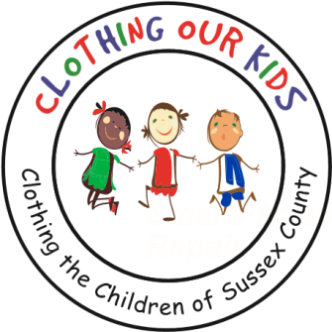
26582 John J. Williams Hwy Ste 2
Millsboro, DE 19966
302-864-KIDS (5437)
www.clothingourkids.org

KRUISIN FOR KIDS
Dear COK Friends,

We have deeply missed our wonderful friends in the community! All at Clothing Our Kids (COK) are genuinely concerned for the children in need of clothing during this most uncertain time.

Although our Volunteer Center is temporarily closed, and we are unsure about what the next school year might bring with a hybrid learning experience, COK is ready to help whether school is in person or not. As you may be aware, we found it necessary to postpone our annual fundraisers – the Spring Auction Party and the Fall Golf Outing – until 2021.
To support the kids of Sussex County we are planning a fun COK event inside The Peninsula with built-in social distancing.

Kruisin For Kids will be a parade of cars throughout our neighborhoods. Entrants are encouraged to be creative in decorating their cars – convertible top down if an option – with a theme depicting highlights from your favorite U.S. State (including DC) or Major Sports Team (The Statue of Liberty, Niagara Falls or the Yankees for NY? The Washington Monument, the Nationals, or the No Name Football Squad for DC?) The date for this event is Saturday September 27 (with a rain date of Wednesday September 30). Decorated cars will gather at 4:00pm in the parking lot near the tennis courts. At the parade’s completion, a Tailgate Party is planned in the starting parking lot where a judging will take place. You might bring your own food or preorder from The Club for delivery to your car (at least 24 hours in advance, please). The Club will also set up a cash bar to purchase beverages of choice. All refreshments are to be consumed in or near cars. (Remember, we are social distancing.) Our favorite DJ will spin tunes and several items will be offered for raffle. Cost per auto entrant is $30 – which includes five raffle tickets – but participants will be encouraged to raise funds from the fans along the route by having envelopes or jars handy for donations. We know there are motorized gems hidden in garages, so this is a fabulous opportunity to show them off while raising funds for the Sussex County kids in need. You may also wish to present your treasures in all their natural beauty sans decorations.

Even if you do not wish to participate with a car, we would love all The Peninsula residents to come out along the parade route and share in the fun while supporting a great cause.

A Car Registration Form and Parade Route Map are attached. For additional information, kindly contact Kathleen Blouin kblouin@outlook.com or (302)236-9825. If you are unable to share in the fun, you might consider a donation by mailing a check to: COK, 26582 John J Williams Hwy, Suite 2, Millsboro, DE 19966. Thanks so much, stay safe out there, and we hope to see all our neighbors on September 27.

