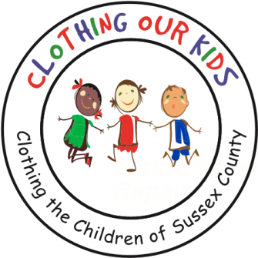
26582 John J. Williams Hwy Ste 2
Millsboro, DE 19966
302-864-KIDS (5437)
www.clothingourkids.org

CLOTHING OUR KIDS (COK) PRESS RELEASE
KRUISIN FOR KIDS RAISES MORE THAN $8000 FOR THE KIDS OF SUSSEX COUNTY
For further information, kindly contact kblouin@outlook.com or (302)236-9825

Due to the pandemic, COK found it necessary to postpone our two annual fundraisers – the Spring Auction Party and the Fall Golf Outing – until 2021. To raise funds for the kids this year, we decided to plan a fun COK event with built-in social distancing.

Kruisin For Kids was a parade of 20 creatively decorated cars – convertible tops down if it was an option – on Sunday September 27 in The Peninsula. All entrants were equipped with butterfly nets to collect socially distanced donations as they passed through neighborhoods, and COK-logoed masks for personal safety. We were pleasantly surprised by the many motorized gems that had been hidden in garages and the imaginative ideas of the participants, so this was a fabulous opportunity to show them off while raising funds for the Sussex County kids in need. We encouraged residents to come out along the parade route and share in the fun while supporting this great cause.

Upon the parade’s completion, a Tailgate Party was held where a judging of the cars took place. First Place went to Joe Saunders wearing a Panda bear suit with loads of children’s toys in his cart, Second Place to John and Delynn Mehrlander highlighting the Kentucky Derby, with Third to Leah Jaffee and crew depicting characters from “The Wizard of Oz”. Cars were parked with an empty space between and refreshments were consumed in or near cars. Our favorite DJ Glenn spun tunes and several items were offered for raffle. A final tally of more than $8000 was raised for the kids.

If you were unable to share in the fun, you might consider a donation by mailing a check to: COK, 26582 John J Williams Hwy, Suite 2, Millsboro, DE 19966. Please stay safe out there!

Clothing Our Kids is a 501(c)3 organization whose mission is to improve the lives of at-risk elementary school children by providing them with appropriate school clothing. To date, COK has provided 137,799 items of school clothing to nearly 25,500 kids.

