KRUISIN FOR KIDS FIRST PLACE WINNER JOE SAUNDERS

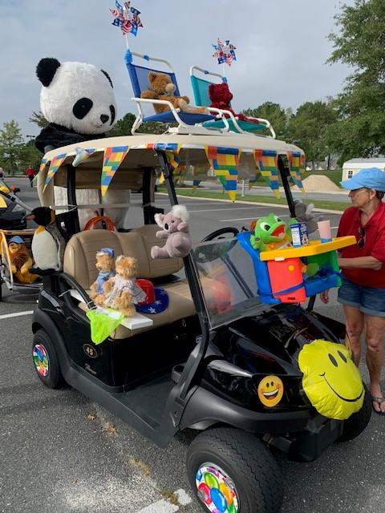

KRUISIN FOR KIDS SECOND PLACE WINNERS JOHN AND DELYNN MEHRLANDER’S KENTUCY DERBY

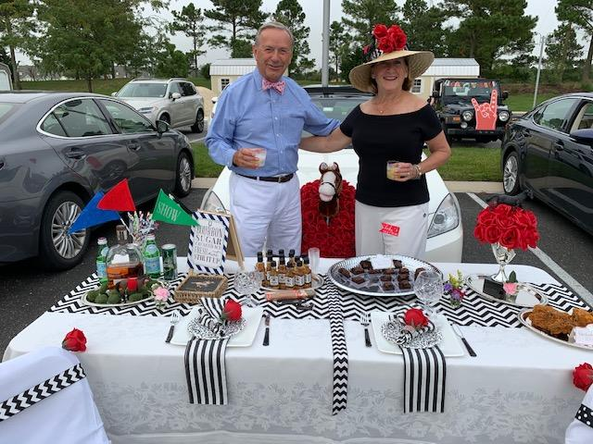

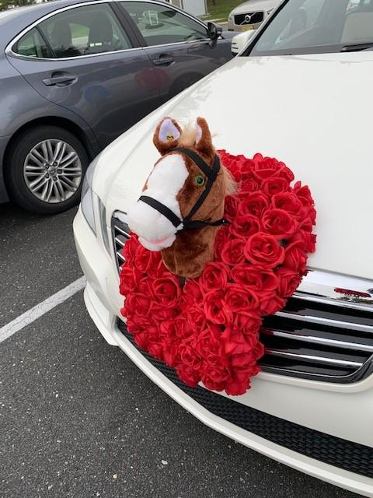

KRUISIN FOR KIDS THIRD PLACE WINNER LEAH JAFFEE & CREW REPRESENTING “THE WIZARD OF OZ”

