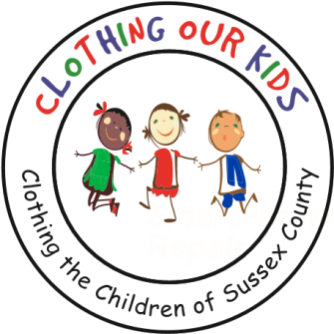26582 John J. Williams Hwy Ste 2

Millsboro, DE 19966

302-864-KIDS (5437)

[www.clothingourkids.org](http://www.clothingourkids.org)

﻿**CLOTHING OUR KIDS PRESS RELEASE**

For further information, kindly contact [kblouin@outlook.com](mailto:kblouin@outlook.com)

THE PENINSULA GOLF AND COUNTRY CLUB TURKEY TROT BENEFITTING COK

On Nov 28th over 50 people participated in the annual Turkey Trot at The Peninsula. COK was designated the beneficiary and participants donated over 150 articles of clothing for Sussex County school kids in need. Thanks to Troon in general and the Staff of the Athletic Club in particular for hosting the fun and necessary event to burn off Thanksgiving calories. On behalf of the kids, we genuinely appreciate all the folks who came out and donated. To donate to COK, kindly send a check to COK, 26582 John J Williams Hwy, Millsboro, DE 19966.

