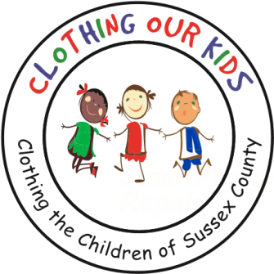
26582 John J. Williams Hwy Ste 2
Millsboro, DE 19966
302-864-KIDS (5437)
www.clothingourkids.org

CLOTHING OUR KIDS ANNOUNCES DATE FOR THE 2021 CHARITY GOLF OUTING – OCEAN ATLANTIC/SCHELL BROTHERS AS TOURNAMENT TRUSTEE
Contact: kblouin@outlook.com, (302)236-9825

For Clothing Our Kids (COK), the major fundraiser is the Golf Outing with the seventh event scheduled for Monday September 27 at The Peninsula Golf & Country Club in Millsboro. The theme for 2021 is “Tee Up For Kids”, and we are extremely fortunate that once again Ocean Atlantic/Schell Brothers is generously supporting this year’s event as the top-level Tournament Trustee.

COK is a 501(c)3 organization whose Mission is to improve the lives of at-risk elementary school children by providing them with essential school clothing. In Sussex County, 24% of children do not have appropriate school apparel which has a direct negative impact on their self-esteem, ability to learn and can lead to bullying. It is COK’s goal to assist these youngsters with an equal start in their early education and help them become successful students. COK works with Assistant Principals, Nurses and Counselors at 34 schools across Sussex County as well as 13 Head Start Programs. To date COK has provided over 26,000 kids with more than 149,000 items of clothing. COK has no paid staff members with 100% of the work carried out by volunteers. In addition, 90% of all funds donated go directly to clothing the kids.

It has certainly been a tough year for everyone, but those already in need before COVID are trying even harder to keep food on the table and roofs over their heads. Kids are suffering from learning in isolation without proper equipment, not knowing if their schools will be open from one day to the next and just frightened about being exposed to the virus when returning to school. We stand by our Mission more than ever to improve their learning experience by providing essential school clothing. There is just so much more need now than ever before and having to cancel last year’s Golf Outing because of the pandemic has been a financial setback for COK.

Please save the date and join Ocean Atlantic/Schell Brothers as a Sponsor. Additional information, including a Sponsorship and Registration Form, can be found on the COK website www.clothingourkids.org. If you just wish to send a donation, kindly mail checks to: COK, 26582 John J Williams Hwy, Suite 2, Millsboro, DE 19966

