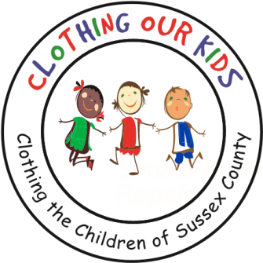
26582 John J. Williams Hwy Ste 2
Millsboro, DE 19966
302-864-KIDS (5437)
www.clothingourkids.org

CLOTHING OUR KIDS (COK) IS PLEASED TO HAVE BEEN CHOSEN AS THE FIRST CHARITY ON THE SUMMER CALENDAR FOR “THANKFUL THURSDAY” BY REVELATION CRAFT BREWING COMPANY ON THE AIRPORT AT HUDSON FIELD BEER GARDEN IN HISTORIC MILTON

Scheduled for Thursday June 3 from 5:00pm to 8:00pm (rain date Wednesday June 9), the night will be filled with food and ice cream trucks, fun and of course, beer. A percentage of beer and food sales will benefit our kids.

Pack a mask and a chair and be ready to be entertained by the children’s band “Hope for Success”. We will roll out our own COK Barrel encouraging guests to bring a new article of school clothing for the pint-sized Sussex County children in need. In addition, a 50/50 raffle is planned along with Donation Yoga lead by Debby Nolan from Yoga Strong who will keep things moving.

Every Thursday this summer the beer garden supports a non-profit under the label of “Thankful Thursday”, which provides an opportunity to give back to the community; to gather people who have not been out lately; to feel safe and to support local non-profits. The Hudson Field Beer Garden has been revamped to ensure the area is as safe as possible. It is people friendly, family friendly with pods for individual seating.

COK’s Mission is to improve the lives of at-risk elementary school children by providing them with appropriate school clothing. Not having essential school clothing has a direct negative impact on their self-esteem, school attendance, ability to learn and can lead to bullying.

