Excerpt from Cape Gazette dated April 17, 2021

By Fritz Schranck

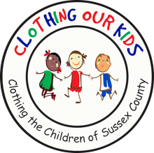 | Clothing Our Kids tournament set for Sept. 27  The seventh Clothing Our Kids tournament will be held Monday, Sept. 27, at The Peninsula Golf & Country Club in Millsboro, with the theme Tee Up For Kids.  COK raises funds to provide shoes and clothing for needy school-age children in every elementary school in Sussex County. Since its inception, the charity has helped more than 26,000 children with nearly 150,000 clothing items.  The pandemic caused the cancellation of last year’s COK events, making this fall’s tournament the first major fundraiser for the organization since 2019.

