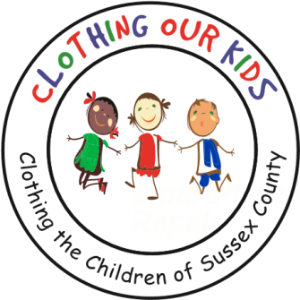
26582 John J. Williams Hwy Ste 2
illsboro, DE 19966
302-864-KIDS (5437)
www.clothingourkids.org

CLOTHING OUR KIDS TO APPEAR ON
DELMARVA LIFE
MONDAY OCTOBER 25 AT 5:00PM
AND RE-AIR 8:00AM ON FOX 21 ON
TUESDAY OCTOBER 26
Contact: kblouin@outlook.com

COK Volunteer Diane Poletti, who serves as Co-Chair of the Special Events Committee, had a chance encounter with an executive at Draper Media a family-owned media company on the Delmarva peninsula. Diane took the opportunity to tell him the compelling Clothing Our Kids story. That conversation resulted in a film crew visiting the COK Volunteer Center. Diane brought together members of the Volunteer Center crew and most importantly Founder Mary Rio to represent COK for the interview. That interview will appear on WBOC’s Delmarva Life airing at 5:00pm Monday, October 25th. WBOC is our local CBS station. It will re-air at 8:00am on FOX21 the next day – Tuesday, October 26th.

This is an extraordinary opportunity to spread the excellent work of COK in supporting the Sussex County School Children in need to the thousands of viewers of both local stations. We hope you will consider tuning in to hear from your fellow COK Volunteers.

IT’S ALL ABOUT THE KIDS!

