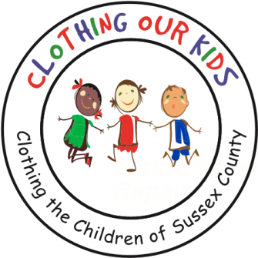
26582 John J. Williams Hwy Ste 2
Millsboro, DE 19966
302-864-KIDS (5437)
www.clothingourkids.org

January 2022
TO ALL VOLUNTEERS, SPONSORS, DONORS AND FRIENDS

Last year reminded us all that we have a superb group of volunteers and supporters. Although we continue to struggle with COVID protocols, the 2021/2022 school year feels like we are nearly back in full force supporting the Sussex County school kids in need. We look forward to 2022 by adding to the total of 27,707 children helped and 160,716 clothing items distributed since 2012.

Some highlights from 2021 are:
- The Board of Directors voted to add middle-schoolers in need of school clothing to the kids COK serves.
- A Leadership meeting in November included reports from the following Committees: Golf, Auction, Community Outreach, Grants, Head Start, Communications, Special Events and New Volunteers.
- Mary Rio’s interview for Delmarva Life which garnered much interest, resulted in several donations and clothing drives.
- Our Golf Tournament and modified on-line Auction Event were held with impressive results. We will need that continued success as we begin serving the Sussex County sixth, seventh and eighth graders in 2022 and beyond.

Finally, I close with some feedback that I received from one of our school nurses. She called to thank COK (which includes all of you) for making one of HER kids smile. She said: “I cannot tell you how much it meant to that little girl when I gave her the new clothing. Her face lit up with the biggest smile!” She went on to say, “As I basked in her wonderful smile I felt like Wonder Woman, a real Hero giving a child a real gift.” What a fitting example of what COK does, not only putting smiles on kids faces but supporting the Heroes in our schools!

On behalf of the Board and myself, thank you all so very much!
We cannot do this without you!

Happy New Year

Bob Blouin
President
IT’S ALL ABOUT THE KIDS

