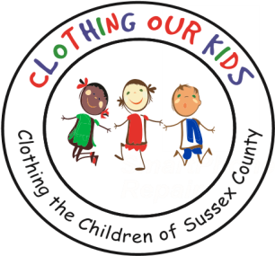
26582 John J. Williams Hwy Ste 2
Millsboro, DE 19966
302-864-KIDS (5437)
www.clothingourkids.org

CLOTHING OUR KIDS (COK) EXPANDS INTO ALL HEAD START PROGRAMS AND MIDDLE SCHOOLS IN SUSSEX COUNTY
COK ANNUAL GOLF OUTING SCHEDULED FOR MONDAY OCTOBER 10
CONTACT: info@clothingourkids.org; (302)236-9825

Founder Mary Rio saw a problem and solved it. Her husband John, an Assistant Principal in a Sussex County Elementary School, told her about a young girl who came to school each day in the same soiled clothing. Mary took it upon herself to clothe this student and learned that she was not the only child attending school wearing insufficient clothing. To address the need, Mary kept inventory in a guest room of her home. When that was not enough to support all those lacking essential school clothing, Mary expanded into her garage. Friends heard of her generosity and wanted to help. Clothing Our Kids was born in 2012 and through generous donations and more than 100 volunteers was able to move the operation into a storefront and eventually grew to fill the Volunteer Center now located on John J Williams Hwy.

The organization receives clothing requests through school nurses, assistant principals, counselors and other administrators who are fully aware of a student’s personal situation. The brand new clothing is packaged at the Volunteer Center, delivered to the school representative making the request and privately handed to the student in need.

COK is now made up of over 150 Volunteers – there is no paid staff – and is solely dependent on donations from our neighbors.

Except for Volunteer Center and warehouse expenses, 89% is spent on program expenses.

Mary Rio supplied 850 items of clothing to 150 students in 2012. Since COK’s founding, more than 28,000 children have received over 165,000 items of clothing.

In celebrating its 10th year, COK is moving into Sussex County Middle Schools. Those in 6th, 7th and 8th grades are as vulnerable and as much in need as their younger counterparts, if not more so. We’re going slowly in this space to ensure we have proper staffing and funds to provide for these students. Hence, we’ll take on one school at a time. After filling the first order for a Middle School student who was placed in foster care, Volunteer Center Director Karen Borges said: “These are the
stories that tear your heart out knowing that she had so little after being left in a foster home. One can only imagine what her young life has been like.” We’re also redoubling our efforts to reach the kids in the Sussex County Head Start Programs. Of course, Head Start was established to help babies living in poverty obtain a “head start” with their education, so we’re aligned in our missions.

As Mary recently said in a tv interview: “It’s not just new clothes, it’s a new life”.

