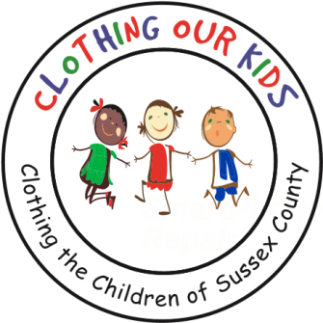
26582 John J. Williams Hwy Ste 2
Millsboro, DE 19966
302-864-KIDS (5437)
www.clothingourkids.org

SUSSEX COUNTY ELEMENTARY SCHOOLS AND HEAD START PROGRAMS SERVED BY COK

Elementary Schools (32)
Benjamin Banneker Elementary School
Blades Elementary School in Seaford
East Millsboro Elementary School
Fredrick Douglass Elementary School
G.W. Carver TOTS Program
Georgetown Elementary School
H.O. Brittingham School
Howard T. Ennis School
Indian River Early Learning Center
J. Clayton Elementary School
Laurel School District
Long Neck Elementary School
Lord Baltimore Elementary School
Love Creek Elementary School
Lu Lu Ross Elementary School
Milton Elementary School
Mispillion Elementary School
Morris Early Childhood Center Program of Sussex County
North Georgetown Elementary School
Phillip C. Showell Elementary School
Phillis Wheatley Elementary School
Rehoboth Elementary School
Richard Shields Elementary School
Seaford Central Elementary School
Seaford Elementary School Homeless Liaison
Southern Delaware School of the Arts
Sussex Academy Elementary School
Sussex County Orthopedic Program, Seaford School District
Sussex Consortium
Sussex Montessori School
TOTS Pre-K Program
West Seaford Elementary School
Woodbridge Early Learning Childhood Education Center

Head Start Schools (11)
Telecom Head Start, Seaford
Telecom Head Start, Lincoln
Telecom Head Start, Annex
Telecom Head Start, Milford
Telecom Head Start Selbyville
Telecom Head Start, Bridgeville
Telecom Head Start, Cool Springs
Telecom Head Start, Dunbar
Telecom Head Start, Milton
Telemon Head Start, Georgetown/Stockley
Telemon Head Start, Southern Sussex (This HS program has never
ordering clothes)

