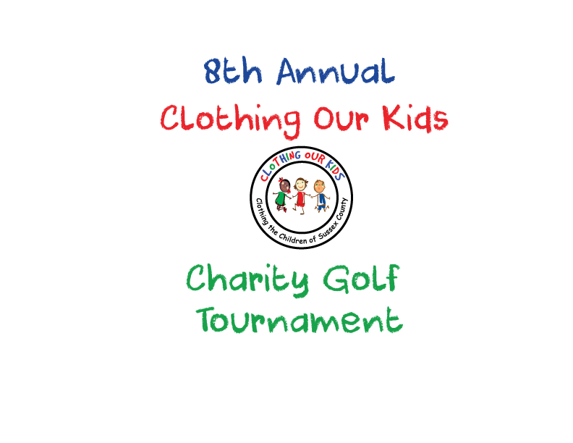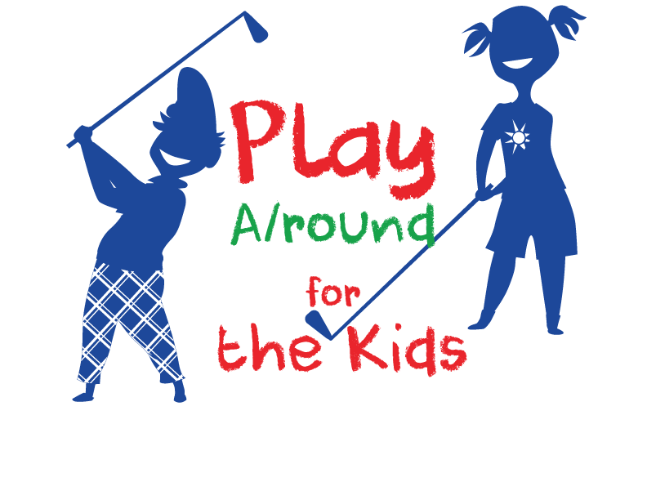

OCEAN ATLANTIC AND SCHELL BROTHERS
GENEROSITY TO THE SUSSEX COUNTY SCHOOL CHILDREN IN NEED CONTINUES
Contact: kblouin@outlook.com

Clothing Our Kids (COK) is once again blessed to have the support and generosity of Ocean Atlantic and Schell Brothers as Tournament Champions for the COK2022 8th Annual Charity Golf Tournament.

The Annual Charity Golf Tournament is the largest fundraiser for the organization which to date has clothed over 28,000 Sussex County School Children with more than 168,000 items. This year to celebrate 10 years of clothing our kids, COK is expanding into the 10 Middle Schools in the County. The COK Golf Outing – which has traditionally sold out – is scheduled for Monday October 10 at The Peninsula Golf & Country Club.

With Ocean Atlantic and Schell Brothers $10,000 sponsorship, a whopping forty students in need will receive a full week’s worth of school clothing which offers them the opportunity to achieve excellence in their education.

As COK Founder Mary Rio recently said: “It’s not just new clothes, it’s a new life.”

