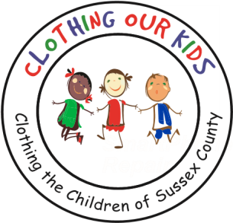
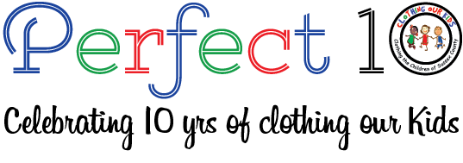

CLOTHING OUR KIDS (COK) PRESS RELEASE
TO THANK THE SCHOOL NURSES, TEACHERS, SOCIAL WORKERS,
ASSISTANT PRINCIPALS, COK VOLUNTEERS DELIVERED HERSHEY BARS
CONTACT: info@clothingourkids.org; (302)236-9825

Those who take care of our children in school are a certain kind of hero. Whether it be a Teacher, a Nurse, a Social Worker, an Assistant Principal, or anyone in school administration, they’ve answered the call to help the kids of the world make a better life for themselves through education. In Sussex County, COK relies on these school representatives to let us know if there are children who might benefit from new clothing in order to have the best learning experience possible. They send in requests to COK on behalf of a child in need, COK fills the order, delivers it to the requesting individual, and that requester hands it to the child discreetly. COK can’t do what it does without these school angels.

In recognition of their kindness and child advocacy, an army of COK Volunteers recently visited each and every school served by the organization delivering a Hershey candy bar to our School Representatives thanking them for the care they take of these children. One Volunteer noted: “What a heartwarming experience as a Teacher choked up saying wonderful things about COK and felt privileged to be helping our organization.” Another met with a Nurse and Guidance Counselor who appreciated what COK does and that it’s done so quickly. One more commented that a Counselor was also very impressed with the speed at which his requests were filled and was thrilled that we’ve expanded the age of the children we serve. Lastly, Nurses at a school were “tickled” at receiving a treat and expressed gratitude for COK as a resource. One stated: “I wish you could see these kids when we do ‘the reveal’ as they are just so happy.” Another Counselor remarked that attendance improves after the kids receive their new clothing. All in all, a great experience for the COK Volunteers who felt rewarded in distributing these candy bars. One saying: “COK Rocks!”

Clothing Our Kids was born in 2012 and through generous donations and 150 volunteers has provided more than 168,000 items of school clothing to nearly 29,000 kids in need. COK believes in offering an opportunity for every child to achieve excellence.

As Founder Mary Rio recently said in a tv interview: “It’s not just new clothes, it’s a new life.”

