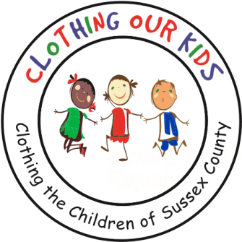
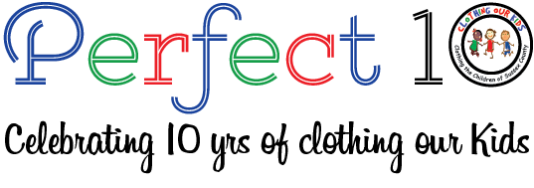www.clothingourkids.org

CLOTHING OUR KIDS (COK) PRESS RELEASE
FROM OUR FOUNDER MARY RIO TO THE 150 VOLUNTEERS
CONTACT: info@clothingourkids.org; (302)236-9825

I want to thank all the volunteers of Clothing Our Kids for their dedication to our organization. I attended the 2022 Volunteer Appreciation event last week. I was amazed by the number of volunteers that attended. The room was filled with some new faces and a lot of familiar faces. This was a special night for me to remember. I could just feel the love and passion and pride I saw in their faces. The event was a “Perfect 10” in every way.

This is our 10th year anniversary. I look back over the years and have so many wonderful (and sometime funny) memories.

Thank you again,
Mary Rio
Founder

Clothing Our Kids was born in 2012 and through generous donations and 150 volunteers has provided more than 168,000 items of school clothing to nearly 29,000 kids in need. COK believes in offering an opportunity for every child to achieve excellence.

As Mary recently said in a tv interview: “It’s not just new clothes, it’s a new life”.

