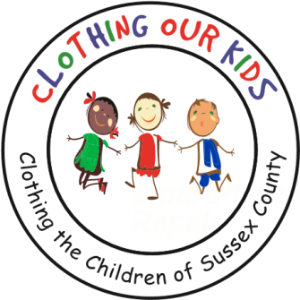
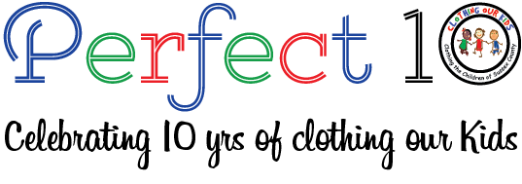

CLOTHING OUR KIDS (COK) PRESS RELEASE﻿
BIG FISH FOUNDATION DONATES CLOTHING AND FUNDS TO SUPPORT THE SUSSEX COUNTY SCHOOL CHILDREN IN NEED
Contact: kblouin@clothingourkids.org; (302)236-9825

Big Fish employees and management supported Clothing Our Kids through a clothing drive and monetary donation. The clothing drive not only included Big Fish employees but involved the Sussex County community as a whole placing bins in their facilities to accept new clothing donations. The clothing drive was organized by Robby Looney of Big Fish. As a result of Big Fish's efforts, over 100 pieces were donated to COK. In addition to collecting new clothing, Big Fish Foundation donated a generous $4,000. On behalf of the KIDS, COK is truly grateful to Big Fish for their efforts.
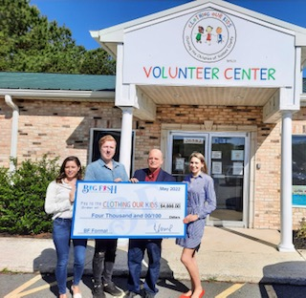
Pictured: Laura Sugrue, Executive Director of Big Fish Foundation; Robby Looney of Big Fish and Organizer of their Clothing Drive; Mike Wezel, COK Vice President; Christophe Emmert of Tunnell & Raysor and a COK Board Member.

Clothing Our Kids was founded in 2012 by Mary Rio and through generous donations and 150 volunteers has provided more than 168,000 items of school clothing to nearly 29,000 kids in need. COK believes in offering an opportunity for every child to achieve excellence.

As Mary recently said in a tv interview: “It’s not just new clothes, it’s a new life”.

