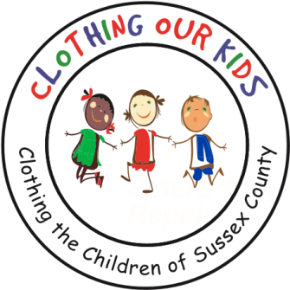
www.clothingourkids.org

CLOTHING OUR KIDS (COK) PRESS RELEASE
ST. EDMOND DONATES $6,000
TO CLOTHE THE SUSSEX COUNTY SCHOOL KIDS IN NEED
CONTACT: info@clothingourkids.org; (302)236-9825

We see the tremendous need but don’t have the capacity to do what Clothing Our Kids does to meet that need, shared Father William T. Cocoa, Pastor of St. Edmond Roman Catholic Church in Rehoboth Beach. Hence, the Pastoral Council voted to provide these funds in support of COK’s Mission to improve the lives of at risk school children in Sussex County by providing them with appropriate school clothing. On behalf of those children, COK is extremely grateful for the continuing generosity of the Staff, Councils and Parishioners at St. Edmond, especially as the organization expands into Middle Schools in addition to the Head Start Programs and Elementary Schools already served.

In Sussex County, many children do not have essential school clothing which has a direct negative impact on their self esteem, school attendance, ability to learn and can lead to bullying. It is COK’s goal to assist these youngsters with an equal start in their education and help them become successful students. As Founder Mary Rio recently said in an interview: “It’s not just new clothes, it’s a new life”.

Clothing Our Kids was born in 2012 and through generous donations and 150 volunteers has provided 170,601 items of school clothing to nearly 29,000 kids in need. COK believes in offering an opportunity for every child to achieve excellence.

