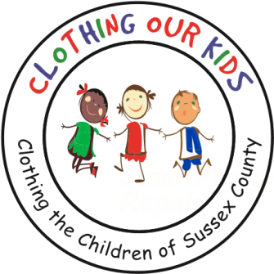
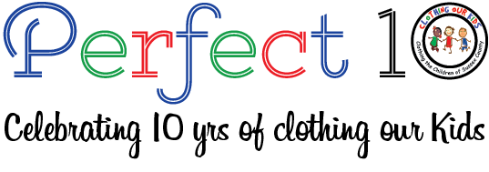www.clothingourkids.org

CLOTHING OUR KIDS (COK) PRESS RELEASE
COK ANNOUNCES NEW BOARD MEMBERS
CONTACT: info@clothingourkids.org; (302)236-9825

To further the Mission of COK, the Board of Directors has unanimously voted to add Diane Poletti and Debbie Polise as two new Members to its roster. The Board is grateful to the service of outgoing Board Members Cheryl Parker, Vice President People at ALOFT AeroArchitects and Kimberly Wright, Director Georgetown Center of the Delaware Adolescent Program, Inc. Their time and talents have been valuable to the Sussex County school children in need over the past two years.

Diane Poletti has been an extremely vital and creative COK Volunteer cochairing the Special Events Committee. During that tenure, she’s been a tireless contributor overseeing numerous clothing drives and events sponsored by the organization. She’s reached out to local media obtaining wonderful coverage for COK and has been a great source of innovative ideas. As a registered and certified school nurse, Diane brings incredible knowledge of what our kids are dealing with and provides that unique experience to the Board.

Debbie Polise jumped in with two feet when the pandemic forced COK to cancel the 2020 Auction. Taking the items collected for that Auction, Debbie turned what was to be a live Auction and developed one online to monetize the items. Debbie comes to COK with vast experience in bulk purchasing. She was the Merchandise Manager for all Delaware State Park Stores negotiating with vendors to obtain the best prices for those establishments providing a great asset to the organization.

Clothing Our Kids was born in 2012 and through generous donations and 150 Volunteers has provided 170,601 items of school clothing to nearly 29,000 kids in need. COK believes in offering an opportunity for every child to achieve excellence. As Founder Mary Rio recently said in an interview: “It’s not just new clothes, it’s a new life”.

