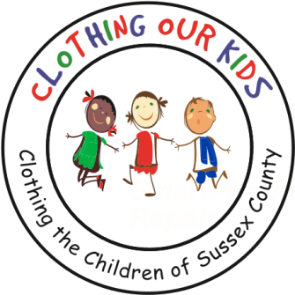
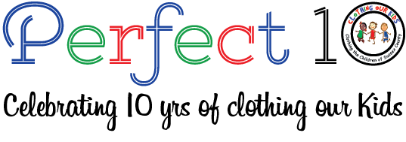www.clothingourkids.org

CLOTHING OUR KIDS (COK) PRESS RELEASE
COK THANKS THE CONGREGATION AT BETHEL UNITED METHODIST CHURCH IN LEWES
CONTACT: info@clothingourkids.org; (302)236-9825

Clothing Our Kids (COK) is totally reliant on financial support from Sussex County neighbors – individuals, businesses, service providers, houses of worship, clubs – to help clothe the school children in need. We are blessed with the generosity of the Congregation at Bethel United Methodist Church in Lewes lead by Pastor Jim Penuel who donated their July collections to our kids. This contribution will be especially helpful as COK expands to provide clothing to students in the 11 middle schools in the County during the 2022/2023 school year. Those in 6th, 7th and 8th grades are as vulnerable and as much in need as their younger counterparts, if not more so. Not having essential school clothing has a direct negative impact on self-esteem, school attendance, ability to learn and can lead to bullying. We’re also redoubling our efforts to reach the kids in the 10 Sussex County Head Start Programs. Head Start was established to support babies living in poverty to obtain a “head start” with their education, so we’re aligned in our missions. Adding middle schools and redoubling efforts with Head Start is of course in addition to the 34 elementary schools already served by COK.

Clothing Our Kids was born in 2012 and through generous donations and the dedicated work of 150 Volunteers has provided 170,601 items of school clothing to nearly 29,000 kids in need at the close of the 2021/2022 school year. COK believes in offering an opportunity for every child to achieve excellence.

As Founder Mary Rio recently said in an interview: “It’s not just new clothes, it’s a new life”.

