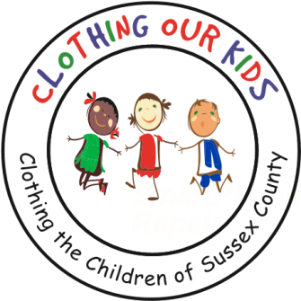
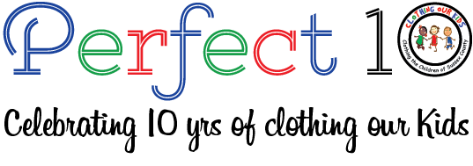www.clothingourkids.org

CLOTHING OUR KIDS (COK) PRESS RELEASE
COK IS BLESSED WITH THE GENEROSTY OF A CLOTHING DRIVE ORGANIZED BY THE SEABROOK COMMUNITY IN MILLSBORO
CONTACT: info@clothingourkids.org; (302)236-9825

The Seabrook Community in Millsboro conducted their first clothing drive to benefit the school children of Sussex County for two weeks in August. In addition to COK receiving a variety of clothing including plus size items, shoes, tops, bottoms and underwear, a monetary donation was made of $490. One member of the group, commented: "I hope this turns into a yearly event." This clothing drive demonstrates the caring and generous nature of the people who live in Seabrook! Pictured below are: Terry Norris, Heather Tschop, and Mary Grace Barbye who delivered the clothing to the COK Volunteer Center on John J Williams Hwy in Millsboro.

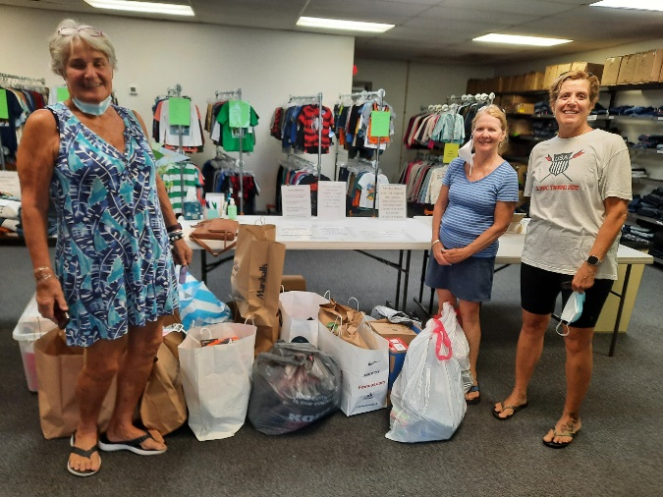

Clothing Our Kids was born in 2012 and through generous donations and 150 Volunteers has provided 170,601 items of school clothing to nearly 29,000 kids in need. COK believes in offering an opportunity for every child to achieve excellence.

As Founder Mary Rio recently said in an interview: “It’s not just new clothes, it’s a new life”.

