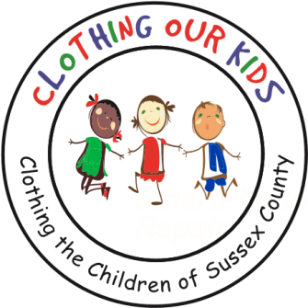
www.clothingourkids.org

CLOTHING OUR KIDS (COK) PRESS RELEASE
ST. MATTHEWS BY THE SEA UNITED METHODIST CHURCH IN FENWICK ISLAND HOSTS A CLOTHING DRIVE TO HELP KIDS SUCCEED IN THE NEW SCHOOL YEAR
CONTACT: info@clothingourkids.org; (302)236-9825

St. Matthews by the Sea UMC ladies' group organized a two-week clothing drive to help kick off the school year. Marilyn Wockley who is pictured in the photo delivered many bags of clothing and $1000 in checks and cash to the COK Volunteer Center in Millsboro. Marilyn stated that she was pleased with her small church's efforts with the clothing drive. COK agrees and believes this little church has a big heart.

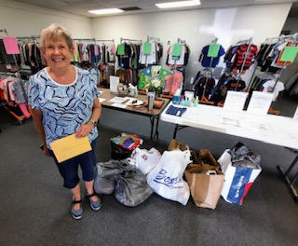

Clothing Our Kids was born in 2012 and through generous donations and 150 Volunteers has provided 170,601 items of school clothing to nearly 29,000 kids in need. COK believes in offering an opportunity for every child to achieve excellence.

As Founder Mary Rio recently said in an interview: “It’s not just new clothes, it’s a new life”.

