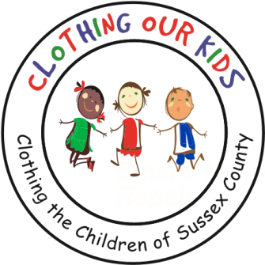
www.clothingourkids.org

CLOTHING OUR KIDS (COK) PRESS RELEASE
THE STONEWATER CREEK WOMEN’S CLUB HOSTS A “HOODIE DRIVE” FOR THE SUSSEX COUNTY SCHOOL KIDS IN NEED
CONTACT: info@clothingourkids.org; (302)236-9825

The Stonewater Creek Women’s Club has once again demonstrated their generosity to Clothing Our Kids by hosting a “hoodie drive” at their monthly meeting on September 7, 2022. A total of 111 zippered hoodies ranging in size from child through adult were delivered to the COK Volunteer Center by Stonewater Creek resident Ellen Herritt. She is pictured below with the amazing collection of hoodies!

What a wonderful way to start the school year with warm hoodies for 111 of our most needy Sussex County children! Many thanks to such a heartwarming and generous community!

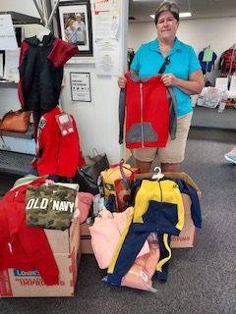

Clothing Our Kids was born in 2012 and through generous donations and 150 Volunteers has provided 170,601 items of school clothing to nearly 29,000 kids in need. COK believes in offering an opportunity for every child to achieve excellence.

As Founder Mary Rio recently said in an interview: “It’s not just new clothes, it’s a new life”.

