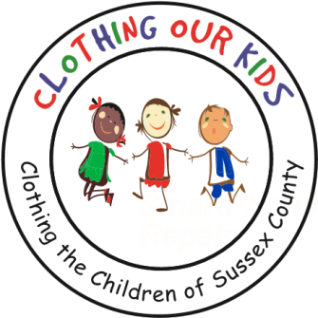
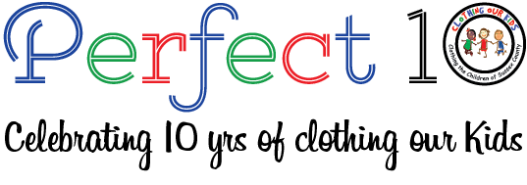www.clothingourkids.org

CLOTHING OUR KIDS (COK) PRESS RELEASE
“UNDERWEAR FOR ALL” DONATES TO COK ON BEHALF OF THE SUSSEX COUNTY SCHOOL KIDS IN NEED
CONTACT: info@clothingourkids.org; (302)236-9825

Clothing Our Kids (COK) works with a variety of organizations throughout Sussex County to fill the clothing needs of neighboring school children living in poverty. One unique program is “Underwear for All” who donated over 130 pairs of girls’ underwear, 130 pairs of boys’ underwear, and 50 camisoles. Tom and Marilyn Wanich helped coordinate this charitable donation. Pictured below is Marilyn as she delivered the underwear to the COK Volunteer Center in Millsboro. Teamwork amongst organizations helps to support our overall community.

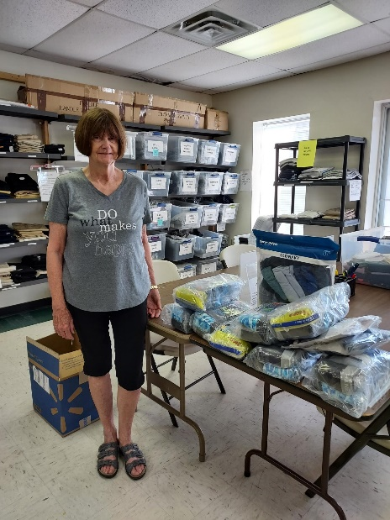
Clothing Our Kids was born in 2012 and through generous donations and 150 Volunteers has provided 170,601 items of school clothing to nearly 29,000 kids in need. COK believes in offering an opportunity for every child to achieve excellence.

As Founder Mary Rio recently said in an interview: “It’s not just new clothes, it’s a new life”.

