FALL CLOTHING DRIVE
@ Georgetown Public Library
123 West Pine Street
Georgetown, DE 19947
October 1 – November 28, 2022

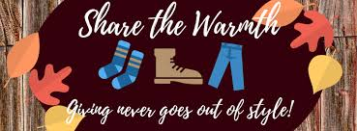
We want to help the kids of Sussex County
WHAT TO BUY:  NEW CLOTHING ONLY  Hoodies, PJ’s, sneakers (not shoes), all school appropriate clothing such as pants and shirts. | SIZES:  Sneaker sizes:  For girls--Sizes child 8 to women’s size 11.  For boys--Sizes child 8 to men’s 13.  Clothing sizes: Pre-school/elementary size 4 to 18/20; Middle school sizes adult S/M/L/XL, as well as juniors for girls (which run 3/5 to 17/19). Plus sizes always needed.

Please help kids in need by donating NEW fall clothes to help them get through the cool weather months. All donations will go to Clothing Our Kids.
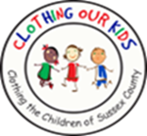
The mission of Clothing Our Kids is to improve the lives of at-risk Head Start through middle school age children by providing them with appropriate school clothing. In Sussex County many children do not have essential school clothing which has a direct negative impact on their self-esteem, their school attendance, their ability to learn, and can lead to bullying. It is our goal to assists these youngsters with an equal start in their early education and help them become successful student.

www.clothingourkids.org

