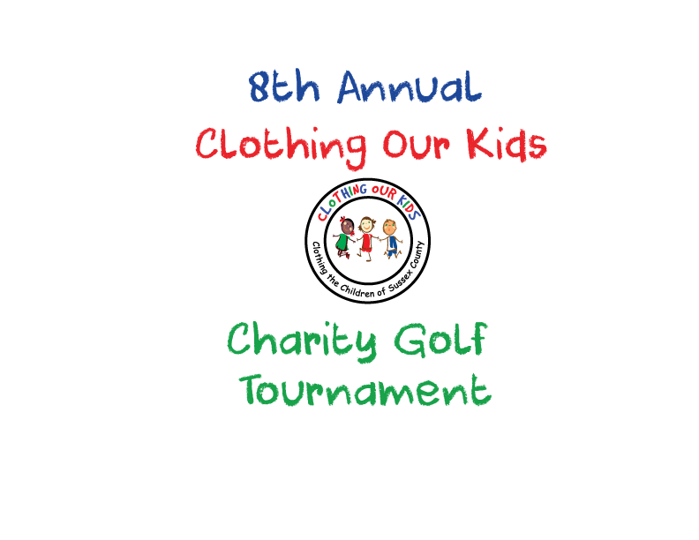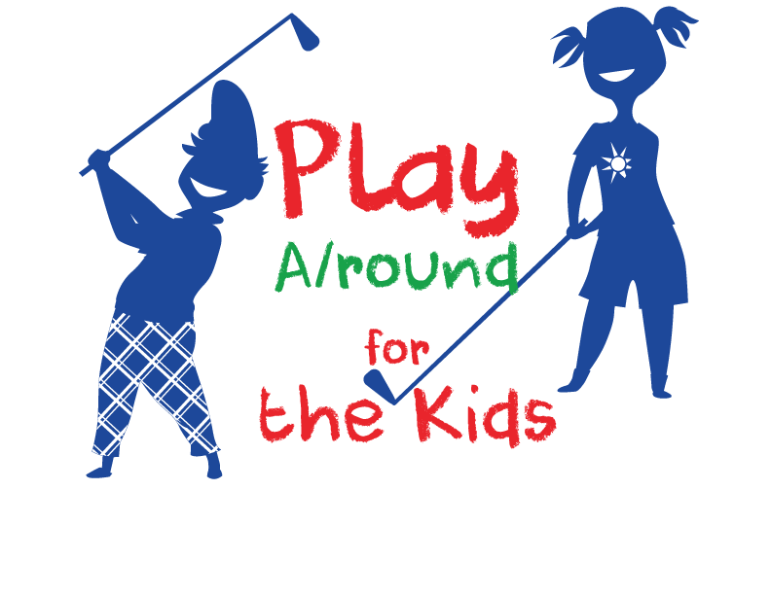
CLOTHING OUR KIDS (COK) PRESS RELEASE
ANNOUNCING MAJOR SPONSORS FOR THE COK 8TH ANNUAL GOLF OUTING MONDAY OCTOBER 10
AT THE PENINSULA GOLF & COUNTRY CLUB
CONTACT: info@clothingourkids.org; (302)236-9825
COK’s largest fundraiser to clothe the Sussex County school kids in need is the Annual Charity Golf Outing. In its eighth year, the 2022 Golf Outing is chaired by Former Board Member Chris Kellogg. COK thanks the following Business Sponsors for their generous support of this year’s event. These sponsorships go a long way in helping to provide an opportunity for every child in our county to achieve greatness.

TOURNAMENT CHAMPION $10,000
OCEAN ATLANTIC & SCHELL BROTHERS

KIDS BOOSTER $5,000
VAL ELLENBERGER, COMPASS REAL ESTATE
MICHELE & JIM LATTANZI, NORTHROP REALTY

PREMIER SPONSORS $3,000
BEACH BABIES
MOUNTAIRE FARMS
SLEEPY TOOTH/PENINSULA DENTAL
TIDEMARK FEDERAL CREDIT UNION

SUPERIOR SPONSORS $2,000
ENVISION EYE CARE
TRINITY FOUNDATION

TOPFLIGHT SPONSORS $1,000
ALLEN HARIM FOODS, LLC
FORT MILES MUSEUM
LANE BUILDERS
TROON PRIVE

COK also appreciates the generous support of many individual neighbors who care greatly about the future of the Sussex County school children in need.

As COK Founder Mary Rio recently said: “It’s not just new clothes, it’s a new life.”

