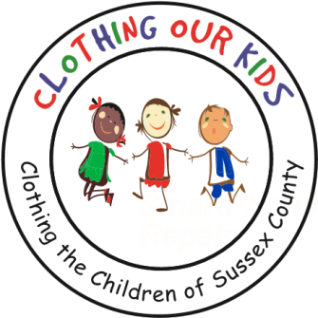
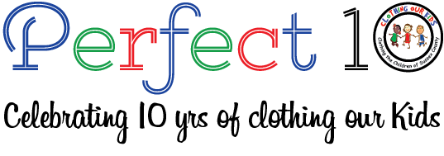

CLOTHING OUR KIDS (COK) PRESS RELEASE
THE KNIGHTS OF COLUMBUS, BISHOP BURKE COUNCIL DONATES WARM COATS FOR THE SUSSEX COUNTY SCHOOL KIDS IN NEED
CONTACT: info@clothingourkids.org; (302)236-9825

Clothing Our Kids was thrilled to receive 47 warm winter coats courtesy of The Knights of Columbus, Bishop Burke Council # 11285. This group is affiliated with Saint Michael the Archangel and Mary Mother of Peace Catholic parishes. On October 6, three of the Knights delivered the coats to the COK Volunteer Center to assist the organization in helping to keep Sussex County elementary and middle school students toasty this winter!

Representing the Bishop Burke Council of the KofC in the picture below are Larry Bucci, Andy Schopfer and Tom Keating with COK Volunteer Janice Fowler and Center Director Karen Borges.

COK’s appreciation for such a generous donation is enormous! Thank you, thank you, thank you!

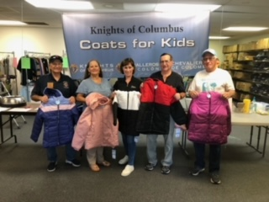
Clothing Our Kids was born in 2012 and through generous donations and 150 Volunteers has provided 170,601 items of school clothing to nearly 29,000 kids in need. COK believes in offering an opportunity for every child to achieve excellence.

As Founder Mary Rio recently said in an interview: “It’s not just new clothes, it’s a new life”.

