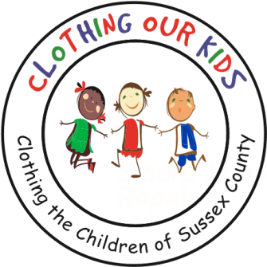
26582 John J. Williams Hwy Ste 2
Millsboro, DE 19966
302-864-KIDS (5437)
www.clothingourkids.org

CLOTHING OUR KIDS PRESS RELEASE
COK 2022 8TH ANNUAL CHARITY GOLF OUTING –
A HUGE SUCCESS
Contact kblouin@clothingourkids.org

Monday October 10 was a stunning day on the links at The Peninsula Golf and Country Club for this year’s major fundraiser. A record 85 Sponsors supported the event with over $100,000 in funds raised to clothe the kids in need at the 10 Sussex County Head Start Programs, 34 Elementary and 10 Middle Schools offering an opportunity for each to achieve excellence.

Over 130 Golfers teed off in a shotgun start assisted by more than 50 Volunteers lead by COK Golf Committee Chair for 2022, Former Board Member Chris Kellogg. First Place went to the team of Alan Friend, Jared Friend, Fran Pratco and Shane Lanhardt, with Tyler Catalina, Les Kincaid, Harry Lidsky and Matt Teeter taking Second Place.

Over 90% of the monies collected will go directly to the kids – there are no paid staff. COK is a 100% local Volunteer organization working directly with school representatives to provide school clothing for the kids who need our help. These Sponsor donations will help to increase the self esteem of these students, ensure better school attendance, reduce bullying, assist them with an equal start in their early education and help them become successful students.

Sincere thanks to all Sponsors, Golfers and Volunteers who made this year’s event a huge success for the Sussex County school kids in need.

As Founder Mary Rio recently said: “It’s not just about new clothes, it’s about a new life.”

