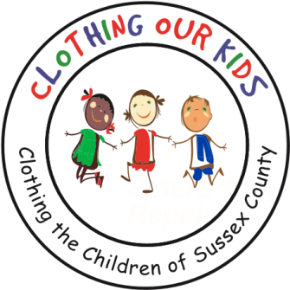
26582 John J. Williams Hwy Ste 2
Millsboro, DE 19966
302-864-KIDS (5437)
www.clothingourkids.org

CLOTHING OUR KIDS (COK) PRESS RELEASE
DRAPER MEDIA BLESS OUR CHILDREN CAMPAIGN AWARDS COK WITH A $2,000 CONTRIBUTION
Contact kblouin@clothingourkids.org

Every year Draper Media works to make the holiday season brighter for Delmarva's less fortunate children with the Bless Our Children campaign. For more than a decade, Draper Media has teamed up with local businesses and members of the community to raise money to buy Christmas presents for needy children in our area. The money raised for Bless Our Children is distributed to charitable groups across the Delmarva Peninsula. These charities then buy gifts for children they know are in need, making sure they have a present to open for Christmas.

Clothing Our Kids, who’s mission is to improve the lives of Head Start, Elementary and Middle School children by providing them with appropriate school clothing, is among the lucky recipients of the Bless Our Children campaign. We are truly grateful to the folks at Draper Media who are responsible for this generous gift to the Sussex County school children in need. We have been told that the contents of packages from COK can make children dance around a room with joy.

As Founder Mary Rio recently said: “It’s not just about new clothes, it’s about a new life.”

