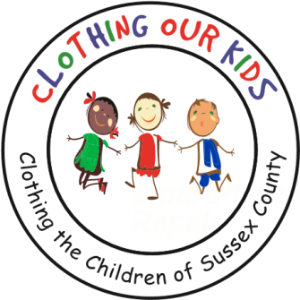
26582 John J. Williams Hwy Ste 2
Millsboro, DE 19966
302-864-KIDS (5437)
www.clothingourkids.org

CLOTHING OUR KIDS (COK) 2022 PRESS RELEASE
GREAT OUTDOOR COTTAGES DONATES $10,000 TO COK AT THEIR GRAND OPENING
Contact kblouin@clothingourkids.org

Made in the USA and built in Sussex County, Great Outdoor Cottages was formed to design and build innovative and high-quality cabins, park models and cottages for the campground and resort industries. Great Outdoor Cottages chose Georgetown Coastal Industrial Park as their home, and at the Grand Opening on December 8, announced a $10,000 donation to Clothing Our Kids.

“We played in the COK2022 Golf Tournament and were so impressed with the work of Clothing Our Kids, that we decided to fully support the organization with this donation”, said Chief Operating Officer Mike Scheid.

Clothing Our Kid depends on the generosity of businesses and individuals in the Sussex County community. Our approach to learning is simple – Let Them Dress for Success. Being the recipient of Great Outdoor Cottages thoughtful gift will clothe many kids in need for the entire school year and could change their lives forever. COK is blessed to have these great new friends.

Pictured left to right is Sussex County Administrator Todd Lawson, Sussex County Council President Mike Vincent, Great Outdoor Cottages CFO John Longino, CEO of Great Outdoor Cottages parent company Blue Water Development Todd Burbage, and COO Mike Scheid. Accepting the big check is COK Secretary and Treasurer Merrill Cohen second from right.

