STEP UP FOR OUR SNEAKER DRIVE!
November 14 - December 14, 2022

Our mission is to partner with Clothing Our Kids to provide NEW sneakers for needy children in Sussex county. As you shop for the holidays, kindly consider picking up an extra pair of sneakers or two and drop them in the bin at our Verizon store locations in Rehoboth, Millsboro and Georgetown. All sneaker sizes from children size 8 through adult are needed and appreciated! Having a new pair of sneakers builds self-esteem, limits bullying, improves school attendance, and keeps their feet warm this winter!

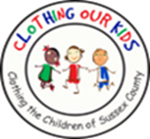
www.clothingourkids.org

