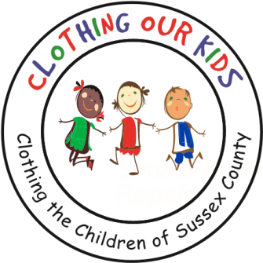
26582 John J. Williams Hwy Ste 2
Millsboro, DE 19966
302-864-KIDS (5437)
www.clothingourkids.org

CLOTHING OUR KIDS (COK) PRESS RELEASE
TWAS THE SEASON FOR GIVING AND COK IS BLESSED TO BE A RECIPIENT OF SO MUCH WONDERFUL GENEROSITY
Contact kblouin@clothingourkids.org

Clothing Our Kids’ Mission is to improve the lives of at-risk Head Start, Elementary and Middle School children by providing them with proper school clothing. As we close out COK’s 10th year, we’ve fulfilled that Mission by supplying over 180,000 items to more than 30,000 kids. None of what COK does is possible without the support and generosity of those in the Sussex County community. We have highlighted many donations leading up to the Holidays, but recently COK has been blessed with more good will, and we truly appreciate the kindness of those below:

- All Saints’ Parish Thrift Shop
- Beacon Pediatrics
- Penelope Danias Fund of the Delaware Community Foundation
- Kings Creek Country Club
- Lewes Presbyterian Church – Mission Committee & Ladies Fellowship Group
- Mason Dixon LAVFW Post 7234 in Ocean View
- The Peninsula Golf & Country Club House Tour Committee
- St. Martha’s Episcopal Church

As Founder Mary Rio recently said: “It’s not just about new clothes, it’s about a new life.”

