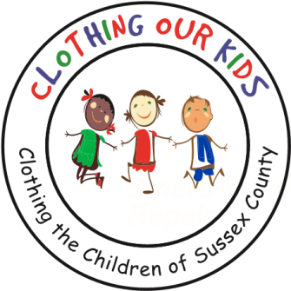
26582 John J. Williams Hwy Ste 2
Millsboro, DE 19966
302-864-KIDS (5437)
www.clothingourkids.org

CLOTHING OUR KIDS (COK)
COK RECEIVES GENEROUS DONATION FROM BEACON PEDIATRICS
Contact kblouin@clothingourkids.org

Once again, the Sussex County school kids in need will benefit from a generous donation provided by the folks at Beacon Pediatrics on John J Williams Hwy in Rehoboth Beach.

A student’s ability has little to do with their background. Kids need HOPE to realize how great they really are. With hope you can literally attain anything. At COK, we believe being proud of your appearance is a good step toward hopefulness. We are truly grateful to Beacon Pediatrics for helping COK provide hope to our kids and the opportunity to achieve excellence.

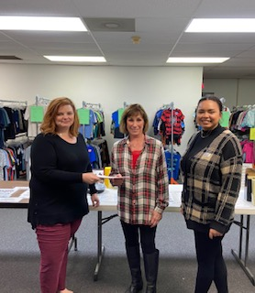
Tracey Howard left and Emma Polite right of Beacon Pediatrics present COK Volunteer Center Director Karen Borges with the donation.

As Founder Mary Rio recently said: “It’s not just about new clothes, it’s about a new life.”

