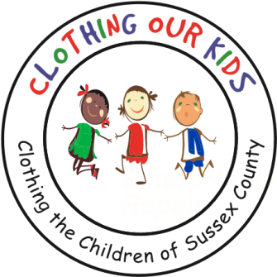
26582 John J. Williams Hwy Ste 2
Millsboro, DE 19966
302-864-KIDS (5437)
www.clothingourkids.org

CLOTHING OUR KIDS (COK)
SANTA LOVES THE SUSSEX COUNTY SCHOOL KIDS IN NEED ENLISTING THE HELP OF THE ELVES AT VANDERWENDE ACRES
Contact kblouin@clothingourkids.org

Santa’s magic was shared with the Sussex County school kids in need as his busy elves were working the annual Santa’s Workshop at Vanderwende Acres. A variety of clothes were donated to the kids including much needed coats, pajamas, pants, tops and sweatshirts.

This was the second year that COK was the recipient of Vanderwende Acres generosity. In addition to a clothing drive, a raffle was held as part of the event with those proceeds also going to COK. The Vanderwende Acres Santa’s Workshop is organized by Caitlin Bunting and demonstrates the goodwill of the holiday season. On behalf of the kids, COK thanks these elves from the bottom of our hearts!

As Founder Mary Rio recently said: “It’s not just about new clothes, it’s about a new life.”

