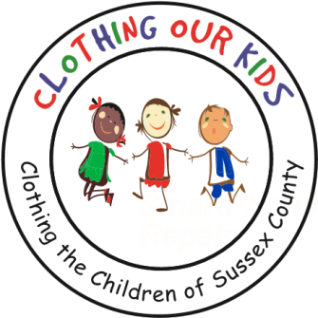
26582 John J. Williams Hwy Ste 2
Millsboro, DE 19966
302-864-KIDS (5437)
www.clothingourkids.org

CLOTHING OUR KIDS (COK)
RECIEVES DONATION FROM FRIENDS IN THE WHITE CREEK AT BETHANY COMMUNITY

Clothing Our Kids was proud to be the recipient of financial donations organized by Sheri Fronczak for her community, White Creek at Bethany. Sheri has numerous neighbors who were former Teachers and fully aware of children in their classrooms needing appropriate school clothing. The community decided that COK would be the perfect beneficiary for their generosity in December 2022. Teachers are true superheroes.
Pictured is Sheri Fronczak holding the checks during a visit to the COK Volunteer Center. Many thanks to Sheri and all of the White Creek at Bethany participants who have helped further the COK Mission to assist these youngsters with an equal start in their early education and help them become successful students!
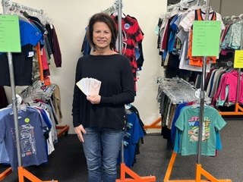
As Founder Mary Rio recently said: “It’s not just about new clothes, it’s about a new life.”

