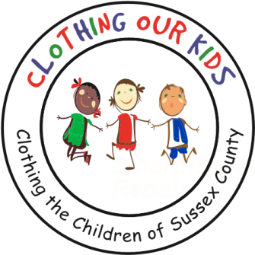
26582 John J. Williams Hwy Ste 2
Millsboro, DE 19966
302-864-KIDS (5437)
www.clothingourkids.org

CLOTHING OUR KIDS (COK) PRESS RELEASE
COK BOARD CHANGES AND A NEW INITIATIVE TO HELP TEACHERS HELP OUR SCHOOL KIDS IN NEED
Contact kblouin@clothingourkids.org

Heather Ennis Sells and Christophe Emmert have transitioned off the Clothing Our Kids (COK) Board of Directors, but Christophe remains as a Legal Advisor while Heather serves as a Community Advisor. We truly appreciate the time and talent these two professionals have provided to COK. COK is thrilled to welcome back Pam Fleuette, CEO of Tidemark Federal Credit Union, to the Board. Pam brings great knowledge of the inner workings of COK, having served on the Board during its early years. Through Pam, Tidemark is a consistent Sponsor, contributor, and general supporter of the organization. Of course, Pam is also an outstanding business leader in the overall Sussex County community.

In addition, COK is extremely excited to officially launch the new School Liaison Program headed by Board Members Diane Poletti and Deb Polise and closely coordinated with the COK Volunteer Center’s School Liaison Cathy Showell. School Liaisons will visit all Sussex County elementary and middle schools and meet with nurses, counselors, assistant principals, social workers, teachers, and any other school representative aware of kids who need appropriate school clothing to better their learning abilities. COK New Volunteer Coordinator Cathy McKinney has been hard at work vetting Volunteers for these positions. In addition COK Head Start Liaison Susan O’Doherty has been working with those programs since before the pandemic. Clothing closets for our KIDS have been set up in several facilities. So far, we’ve brought on Liaisons to cover 55 Sussex County schools.

COK is sure to learn a lot and hopes to assist the valuable educators as the School Liaisons speak directly to all Sussex County school personnel.

As Founder Mary Rio recently said: “It’s not just about new clothes, it’s about a new life.”

