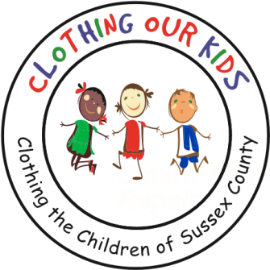
26582 John J. Williams Hwy Ste 2
Millsboro, DE 19966
302-864-KIDS (5437)
www.clothingourkids.org

CLOTHING OUR KIDS (COK) PRESS RELEASE
TCC GIVES, J&J BAGELS AND COK PARTNER TO HELP TEACHERS HELP OUR KIDS AND WITH BAYSHORE COMMUNITY CHURCH TO KEEP THE COK VOLUNTEER CENTER SPARKLING
Contact kblouin@clothingourkids.org

TCC Gives, J&J Bagels, and COK formed a partnership to supply breakfast for all staff at East Millsboro Elementary and Millsboro Middle Schools during the month of February. Helping to launch the new In-School Liaison Program, TCC Gives approached COK to provide a venue to talk about the initiative bringing on board J&J Bagels to cater food and beverages. The purpose of COK School Liaisons is to visit every Sussex County Head Start, Elementary and Middle school to meet personally with all representatives who might be aware of kids needing appropriate school clothing to better their learning abilities. Over 180 staff members enjoyed the breakfasts, giving COK School Liaisons Kathy Lane and Suzi Pashuck a platform to speak with them about the Mission of COK. The school personnel were thankful not only for the breakfasts but in learning that COK offers an opportunity for every child to achieve excellence. In addition to the breakfasts, teachers had a chance to win one of 10 $1000 Amazon gift cards provided by TCC Gives.

One of the stories told by COK was that of a five-year-old boy's house burning down last year. The family escaped with only the clothes on their backs. East Millsboro Elementary School contacted COK requesting clothing for the boy. When the secretary at the school presented the little boy with his clothing, he was so excited to find packaged underwear in the box. COK hears so many stories of children never having packaged clothing or those with new tags. This story proves how COK can truly influence a child’s path in life.
In another extraordinary gesture of kindness, employees of TCC Gives and pastor Chase Ferruccio with congregation members of the Bayshore Community Church volunteered to deep clean the COK Volunteer Center on a regular basis. Center Director Karen Borges said: “I ran into the Center this morning to get something and to my wonderful surprise we were all cleaned up and even smelling good! It looks fantastic and your gang did a wonderful job. It’s been a while since we’ve had a complete clean like this and I am so appreciative of your helping COK! You guys ROCK!”
It takes a village, and COK is truly grateful for partners like TCC Gives and Bayshore Community Church.
As Founder Mary Rio recently said: “It’s not just about new clothes, it’s about a new life.”

