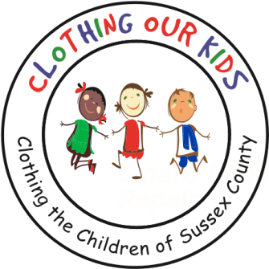
26582 John J. Williams Hwy Ste 2
Millsboro, DE 19966
302-864-KIDS (5437)
www.clothingourkids.org

CLOTHING OUR KIDS (COK) MARCHES ON
WINS FIRST PLACE IN COMMUNITY FLOAT CATEGORY AT LEWES CHRISTMAS PARADE SATURDAY DECEMBER 3

Saturday December 3 marked the inaugural debut of the Clothing Our Kids “float” in the Lewes Christmas Parade. Led by Chief Creative Elf Gabi Tapkas, a fantastically detailed Golf Cart was transformed into the float by Driver Elf and Polisher Extraordinaire Jeff Tapkas. Marching alongside the float were the Elf Girls: Merry Elf (Board Member Debbie Polise), Jolly Elf (Volunteer Center Manager Jane Smeland), Sporty Elf (Doris Stellings), Posh Elf (Susan Greally), Happy Elf (Eileen Wilkinson) and Cheery Elf (Kathleen Blouin). There were also two Elf Boys: Friendly Elf (Scott Wilkinson) and Buddy (President Bob Blouin). Special guest and kid favorite Panda(monium) Joe Saunders rounded out the group. AND COK TOOK FIRST PLACE IN COMMUNITY FLOAT CATEGORY!

The COK Elves also paraded in the Rehoboth Beach Christmas Parade Monday December 5 joined by Festive Elf Janice Fowler. Committee Members behind the scenes included: Engineering Elves Nick Ruhle and John Plum along with Supporting Elves Janis Galvin and Margaret Muller.

COK is truly blessed with passionate, kind, generous, creative and hard working Volunteers, and is extremely grateful to everyone who puts in so much effort on behalf of OUR KIDS!

As Founder Mary Rio recently said: “It’s not just about new clothes, it’s about a new life.”

