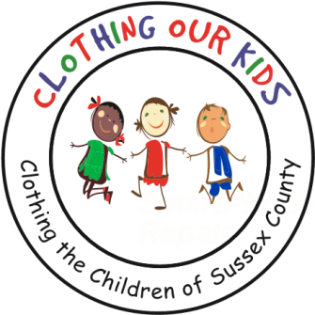
26582 John J. Williams Hwy Ste 2
Millsboro, DE 19966
302-864-KIDS (5437)
www.clothingourkids.org

CLOTHING OUR KIDS (COK)
VOLUNTEERS COLLECT PERSONAL HYGIENE ITEMS FOR THE SUSSEX COUNTY SCHOOL KIDS IN NEED
Contact kblouin@clothingourkids.org

Huge thanks to a wonderful group of Volunteers and their neighbors who came through for Clothing Our Kids. COK needed personal hygiene items to distribute to our kids in need and they literally filled an SUV with the necessary items. Special appreciation goes to Sandy Wofgang, Sharon Kelly O’Brien, Kelsey O’Brien, Justin Sincavage, Linda Schnell, and Patty Casey.

With COK now serving Sussex County Middle School kids in need, we’re learning a lot. In addition to clothing, these more senior children require hygiene items that are not as necessary for younger students. It’s a bit outside our wheelhouse but we are extremely grateful to these Volunteers and their neighbors who have stepped in to fill that void. It takes a village to raise children, and COK truly appreciates these very special villagers.
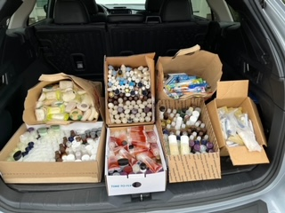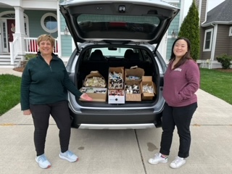

“We Can’t Help Everyone, BUT… Everyone Can Help Someone.” – Dr. Loretta Scott

