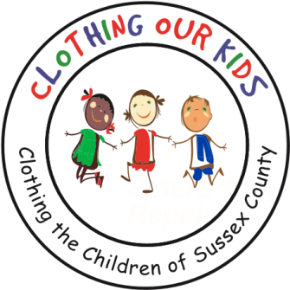
26582 John J. Williams Hwy Ste 2
Millsboro, DE 19966
302-864-KIDS (5437)
www.clothingourkids.org

CLOTHING OUR KIDS (COK) PRESS RELEASE MAY 15
COK RECOGNIZES THE SUSSEX COUNTY EDUCATORS WHO ARE SO FUNDAMENTAL TO THE SUCCESS OF OUR CHILDREN
Contact kblouin@clothingourkids.org

A Teacher has been defined as “an expert who is capable of imparting knowledge that will help learners to build, identify and to acquire skills that will be used to face the challenges in life.” Teachers play vital roles in the lives of the students left in their care. They typically do not think of themselves as role models, however, inadvertently they are and may be the only positive role model in a child’s life.

COK asks the Sussex County Elementary and Middle School Teachers to also be on the lookout for a child in need of sufficient clothing. Together we can provide them with a sense of dignity and help them be more at ease as they learn. When these kids don’t have to worry about basics such as clothing, they’re more eager to attend school and become successful students. The goal of this partnership? Together we wish to establish an environment where children focus their efforts on learning while being more comfortable around their peers.

To show appreciation for our Teachers, an army of COK Volunteers recently visited each school served by the organization delivering candy bars while thanking them for the care they take of our KIDS. One recipient from the Indian River School District Early Learning Center said: “Thank you so much for reaching out! Things are going great with the program. We use COK quite often and appreciate the support it offers to our students and families.” And another: “We are extremely excited that you’ve included us in your program. We appreciate your organization and volunteers. It’s been a great help to many of our kids. We look forward to working with you more in the coming years.”

Engineers make bridges, Artists make paintings. Scientists make rockets. But Teachers make them all.
