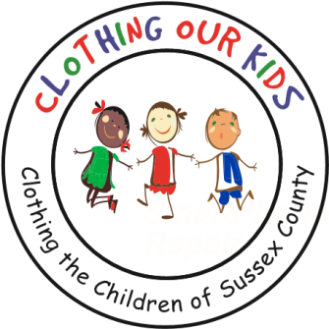
26582 John J. Williams Hwy Ste 2
Millsboro, DE 19966
302-864-KIDS (5437)
www.clothingourkids.org

CLOTHING OUR KIDS (COK) OCTOBER 25
EVERLASTING HOPE MINISTRIES SPONSORS A CLOTHING DRIVE FOR THE SUSSEX COUNTY SCHOOL KIDS IN NEED
Contact kblouin@clothingourkids.org

Everlasting Hope Ministries in Georgetown recently sponsored a clothing drive to benefit Clothing Our Kids, which provides free clothing items including jackets and shoes to the Sussex County school kids in need. Pictured below are Pastor Tony and Lady Venessa Neal. Lady Vanessa worked with parishioner Peggy Trott to organize the clothing drive. Peggy Trott is the mother of COK Board Member Kaniesha Trott-Savage.

The Ministries collected much needed jeans, coats, tops, underwear, and socks which will offer an opportunity for many Head Start, Pre-K, Elementary and Middle School children to achieve excellence in their learning years. We are extremely grateful to the Everlasting Hope Ministries for their generous donation.
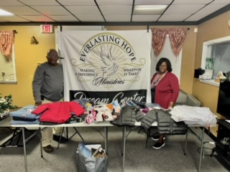

“It is easier to build strong children than to repair broken men.” – Frederick Douglass.

