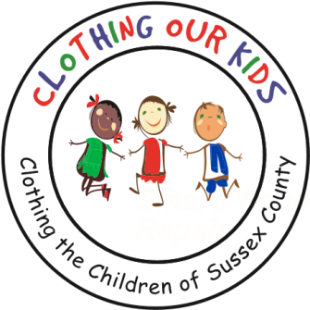
26582 John J. Williams Hwy Ste 2
Millsboro, DE 19966
302-864-KIDS (5437)
www.clothingourkids.org

CLOTHING OUR KIDS (COK) – NOVEMBER 6
ONCE AGAIN, THE CHARITABLE KNIGHTS OF COLUMBUS COME THROUGH FOR THE SUSSEX COUNTY SCHOOL KIDS IN NEED
Contact: kblouin@outlook.com
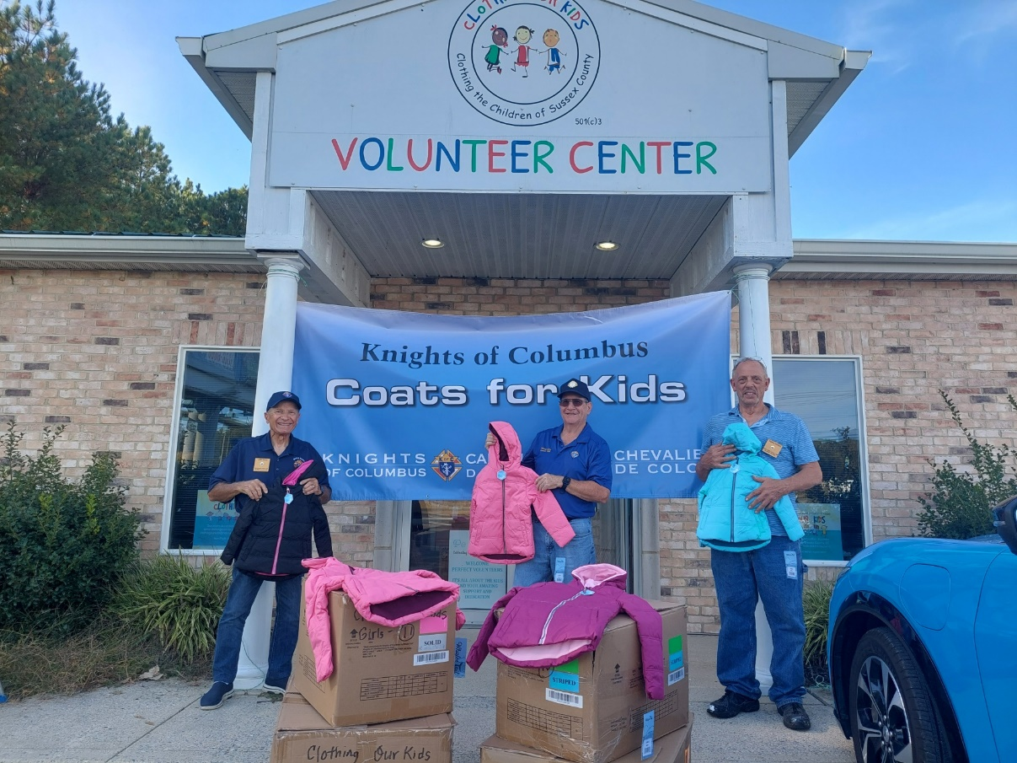

As has been their tradition for the past few years, the Knights of Columbus purchased 40 coats to keep Sussex County Head Start, Pre-K, Elementary and Middle School children cozy and warm as they head out to school on cold winter mornings. For the Knights of Columbus, charity means supporting a virtually boundless variety of projects. COK is extremely blessed to be chosen as one of their projects.

In the photo above are Coats for Kids Chair Larry Bucci, Past Grand Knight Andy Schopfer, and Council Grand Knight Dennis Barnes from Millsboro’s Bishop Burke Council #11258 in front of the COK Volunteer Center.

“Never doubt that a small group of thoughtful committed citizens can change the world. Indeed, it’s the only thing that ever has.” – Margaret Mead

